**Pizza Sales SQL Queries**

**A**.**KPI’s**

--1.Total Renevenue

select sum(total_price) as total_revenue from dbo.pizza_sales

--2. Average Order Value

select (sum(total_price)/COUNT( distinct order_id)) as avg_order from dbo.pizza_sales

--3. Total Pizza Sold:

select sum (quantity) as total_pizza_sold from dbo.pizza_sales

--4. Total Order

select count(distinct order_id) as total_order from dbo.pizza_sales

--5. Average Pizza Per Order

select cast(cast(sum (quantity) as decimal(10,2))/cast(count(distinct order_id) as decimal(10,2)) as decimal(10,2)) as Avg_Pizza_per_order from dbo.pizza_sales

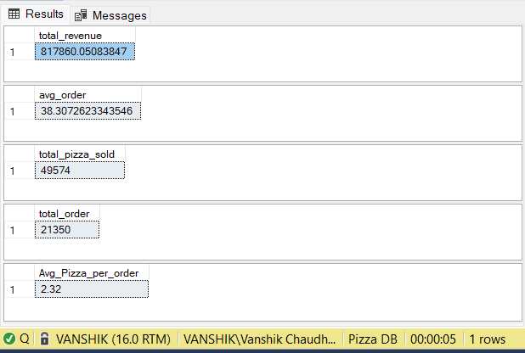

**B**. **Daily Trend For Total Orders**

--1. Daily Trend For Total Orders

select DATENAME(DW,order_date) as Order_day, COUNT(distinct order_id)

as total_orders from dbo.pizza_sales

group by DATENAME(DW,order_date)

--2. Montly Trend For Total Orders

select DATENAME(MM,order_date) as Order_Month_Name, COUNT(distinct order_id)

as total_orders from dbo.pizza_sales

group by DATENAME(MM,order_date)

order by total_orders desc

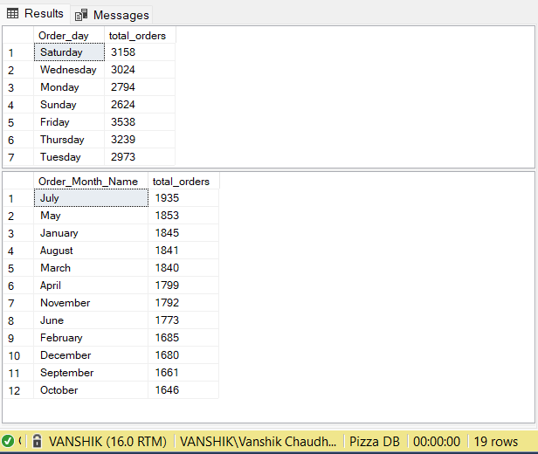

--3. Percentage of Sales By Pizza Category

select pizza_category,cast(sum(total_price) as decimal(10,2)) as total_price,cast(sum(total_price)*100/

(select sum(total_price)

from dbo.pizza_sales where MONTH(order_date) = 1

) as decimal(10,2)) as Total_percentage_sales from dbo.pizza_sales

where MONTH(order_date) = 1

group by pizza_category

order by Total_percentage_sales desc

--4. Percentage of Sales By Pizza size

select pizza_size,cast(sum(total_price) as decimal(10,2)) as total_price,cast(sum(total_price)*100/

(select sum(total_price)

from dbo.pizza_sales

) as decimal(10,2)) as Total_percentage_sales from dbo.pizza_sales

group by pizza_size

order by Total_percentage_sales desc

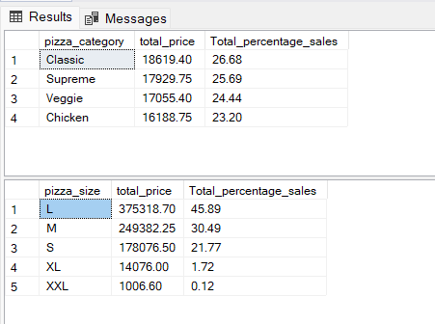

--5. Top 5 Pizzas by Revenue

select top 5 pizza_name, sum(total_price) as total_revenue from dbo.pizza_sales

group by pizza_name

order by total_revenue desc

--6. Bottom 5 pizzas By revenue

select top 5 pizza_name, sum(total_price) as total_revenue from dbo.pizza_sales

group by pizza_name

order by total_revenue asc

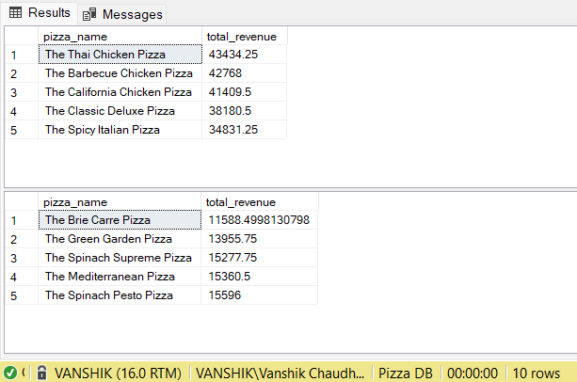

--7. Top 5 Pizzas by Quantiy

select top 5 pizza_name, sum(quantity) as total_quantity from dbo.pizza_sales

group by pizza_name

order by total_quantity desc

--8. Bottom 5 pizzas By Quantiy

select top 5 pizza_name, sum(quantity) as total_quantity from dbo.pizza_sales

group by pizza_name order by total_quantity asc

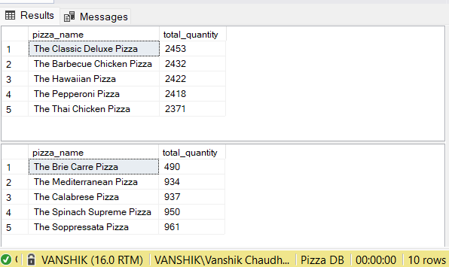

--7. Top 5 Pizzas by Total Orders

select top 5 pizza_name, COUNT(distinct order_id) as total_order from dbo.pizza_sales

group by pizza_name

order by total_order desc

--8. Bottom 5 pizzas By Total Orders

select top 5 pizza_name, COUNT(distinct order_id) as total_order from dbo.pizza_sales

group by pizza_name

order by total_order asc

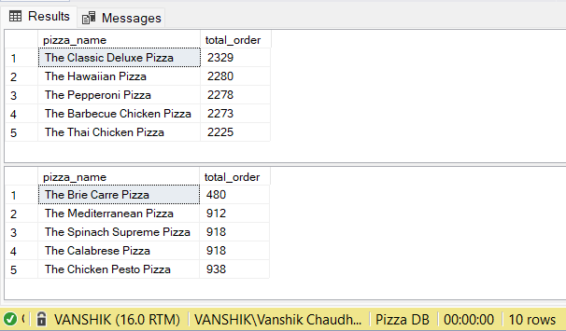

**NOTE :-**

If you want to apply the pizza_category or pizza_size filters to the above queries you can use WHERE clause. Follow some of below examples

SELECT Top 5 pizza_name, COUNT(DISTINCT order_id) AS Total_Orders

FROM pizza_sales

WHERE pizza_category = 'Classic'

GROUP BY pizza_name

ORDER BY Total_Orders ASC

**Note:-**

Tool is used MySQL Server, MS PowerBI and MS Advance Excel